We know that [Scrum](http://www.scrumalliance.org/) provides an Agile software development methodology, but how does it support innovation?

The truth is that while Scrum provides the mechanism to react to the innovative ideas coming down from Product Management, via an ever changing prioritized backlog, incremental delivery, and frequent opportunity for customer feedback, it provides nothing explicitly to support proactive product innovation within an engineering organization.

In addition, while Scrum provides the mechanism for teams to identify process and practice innovations, through the Sprint Retrospective, there is no built in methodology for prioritizing this non-product work against the product work in the backlog.

Over the years I have found that engineering organizations are routinely confounded by these lackings of Scrum, and have seen several different methodologies to enable engineering led innovation flow.  My favorite is to build into your existing Scrum development process a bottom-up innovation feedback loop.

This feedback loop incorporates the [Lean Startup](http://theleanstartup.com/principles) concept of a build-measure-learn cycle in order to achieve the twin goals of rapid validation and failing fast.   Here’s how it works…

### ****COMMITMENT TO INVEST IN INNOVATION****

To start with there must be a commitment to invest in innovation from the organization.  Innovation is not free, but if harnessed it can pay for itself through operating efficiencies and product improvements.

Google famously utilized a [70/20/10](http://en.wikipedia.org/wiki/70/20/10_Model) innovation investment approach with its engineers, where 70% of time was spent working on core product development objectives, 20% of time on innovation around core products and 10% on any innovation idea an engineer wished to pursue.

Many organizations would balk at allocating that much capacity away from core product development and Google has since put more constraints on the approach, but the core principal has been widely adopted; allocate some percentage of engineering, every iteration, to innovation.

### ****TRACKING THE INNOVATION BACKLOG****

Once this commitment has been made, track this innovation budget with time-boxed stories in the product backlog which will be executed each sprint.  Seed the stories with aspiration goals, not traditional acceptance criteria.  These goals can come from Product Management, discipline leaders within the engineering organization or the engineers themselves.

The point is that they represent clear visions of problems to be solved, not of solutions. The moment they start requiring acceptance criteria it’s no longer innovation, it’s product development.

Product Owners have the responsibility to weigh these innovation goals against one another when prioritizing the innovation backlog, but they do not get to defer the expenditure of the innovation budget in order to pursue project goals.

### ****INNOVATION GAME****

Incorporate into each sprint review an innovation game similar to the[buy-a-feature game](http://www.innovationgames.com/buy-a-feature/).  Allow time for the engineers to demonstrate their progress towards their innovation goals, gain feedback, and pitch to stakeholders why further investments in innovation in a certain area are valuable.

Attendees are then each given some hypothetical investment budget, say $5, and allowed to allocate that budget as they see fit towards incrementing any of innovation areas further.  The product owner uses the results of the game to re-prioritize the innovation backlog, throwing out the ideas that did not generate enough market interest and focusing the future expenditure of the innovation budget on those that did.

Side benefit, I’ve seen this activity motivate stakeholders, especially within the engineering organization, to attend sprint reviews more often in order to influence this process.

Sounds easy right?  Not so fast.  While this feedback loop provides the mechanism for innovation flow, the spigot still has to be turned on.  For that an organization needs to look deeply at its cultural makeup, to make sure that its actions demonstrate that it values creative thinking, experimentation and candid feedback.

Engineers have to trust that it’s ok to fail.  They also have to be enabled with the space, time, and tools required for innovative work.  Once established you may likely find that your innovation budget results in some of the highest ROI opportunities and engenders a closer partnership in product development between engineering and product management.

If you look at Gartner's Pace-Layered Application Strategy, you'll note three layers:

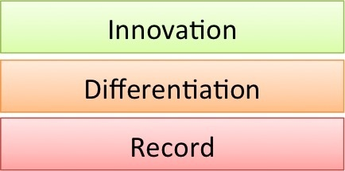

[**http://davidjcmorris.com/index.php/2013/08/keeping-pace-a-layered-approach-to-achieving-agility/**](http://davidjcmorris.com/index.php/2013/08/keeping-pace-a-layered-approach-to-achieving-agility/)

I'm very interested in this topic. I even asked a related question: [What would be a practical approach to manage innovation in a software company of medium to small size?](https://www.quora.com/What-would-be-a-practical-approach-to-manage-innovation-in-a-software-company-of-medium-to-small-size)  
  
Just a couple of Mike Cohn's quotes (one of the contributors to the invention of the Scrum):  
  
1. Read in [Should Agile Projects Be Innovative?](http://www.infoq.com/news/2015/01/agile-innovation)

   Scrum in the mid-1990s (as I implemented it and saw it implemented back then) was all about finding innovative solutions. Teams were given a problem, and given a month (or four weeks) to solve the problem. With that much time, teams were able to try one or more potential breakthrough approaches before having to revert back to a safer, tried-and-true approach.  
    In today’s version of Scrum, many teams have become overly obsessed with being able to say they finished everything they thought they would. This leads those teams to start with the safe approach. Many teams never try any wild ideas that could lead to truly innovative solutions.

2. "The plus 1 week", a technique that comes from Mike Cohn's book "Agile Estimating and Planning" (read in  Ron Miller's blog: [Innovation in Scrum: The plus 1 week](http://lifefive.blogspot.com/2009/07/innovation-in-scrum-plus-1-week.html)). 

Each team member would pick one or two projects that they could complete within the week's time. They would then work independently during the week and at the end of the week we would hold a "Show N Tell" session where we would invite all of the other scrum teams to see the work that was done.

Some famous innovation management policies that could be mixed with Scrum:  
  
1. Google 20% policy: [How does Google’s Google Innovation Time Off (20% time) policy work in practice?](https://www.quora.com/How-does-Google%E2%80%99s-Google-Innovation-Time-Off-20-time-policy-work-in-practice)  
  
2. Apple's Blue Sky Program: [Apple’s Blue Sky Is Providing More Employee Perks](http://applemagazine.com/apples-blue-sky-is-providing-more-employee-perks/3088)  
  
3. Corporate hackathons (usually with prices) used in companies like Twitter, Facebook, Google, Yahoo, LinkedIn, eBay and Atlassian.   
  
I'd love to know more policies like these.

[**Strategies for generating creative and innovative ideas in Scrum Teams**](http://agileatlas.org/articles/item/strategies-for-generating-creative-and-innovative-ideas-in-scrum-teams)

Category: Commentaries

Written by: Francesco Attanasio

**Introduction**

This article analyzes how to maximize team creativity and how we as ScrumMasters or Agile Coaches could cultivate the creative potential of our teams for innovation purposes.

Like anything, creativity and innovation can flourish when implemented with the right tools.  
This article explores the conditions in the work environment that helps to encourage team creativity, such as diversity among team members.

In addition, it describes team methods for promoting creativity, including techniques such as brainstorming and lateral thinking.

The main question, for me and one of my ScrumMaster mate, that was running through our mind recently was: “How can we promote creativity for innovation in our teams?”

Before giving an answer to our main question, we had to clarify: how can we try to define Creativity and Innovation?

People constantly ask me how to sell Scrum either to management or to developers. The real question has nothing to do with Scrum. It has to do with leadership and how do you persuade people to change from an old way of doing things to a new way.

Taichi Ohno, the father of the Toyota Production System, was constantly asked this question. His book on Workplace Management is from talks he gave to management and workers and the first talk is on the art of persuasion.

His comments reflect real genius. They articulate what artificial intelligence programmers found out when trying to build robots in the 1980s. Half of what people think is wrong. The challenge is to inspect and adapt to find out what opinions, thoughts, or ideas are wrong. They found that robots would not work unless they programmed this into the robots.

I've found that this is one of the core principles essential to innovation and one of the most important ideas that any person can incorporate into their being. Without it you will fail half the time. With it you will still fail half the time, but inspect and adapt, see problems quickly and recover. People will say you are a "wise" man or woman and that you know more than the rest of us. They will follow such an "expert" because they trust them to navigate through a world of increasing uncertainty.

The Wise Mend Their Ways - Taichi Ohno

**Creativity** is characterized by the ability to perceive the world in new ways, to find hidden patterns, to make connections between seemingly unrelated phenomena, and to generate solutions.  
Creativity involves two processes: thinking, then producing.

In its simplest rendition, innovation is coming up with ideas and bringing them to life. Hatching ideas is the “creative” part; bringing them to life successfully in the form of a new product or service or management method is what makes a raw idea an innovation.

**Innovation** includes all aspects of value creation:

›       Taking new technologies, products and services to the market

›       New business models and ways to create value for customers

›       Improving our internal processes and ways of working

To use “innovation” as a way to stimulate growth means that you offer your stakeholders something new. Something they cannot get anywhere else, something that solves their problem in a superior way or provides unique or exceptional value.

Coming back to our main question as Agile Coaches we think that first of all we need for our teams are three essential ingredients: time to think, diversity and open communication.

***Time to think***  
A work environment must give people **time to think**, **reflect**, **experiment and explore options**. Some business cultures naturally develop along these lines. In others, it’s necessary to promote this attitude by officially setting aside time.

Giving people **time to think**and reflect involves reserving time, during a Sprint and also**protecting** that time from being occupied upon by other tasks.

***Diversity***  
Different people bring different knowledge, cultural backgrounds, types of education and job experience to your team. They have diverse attitudes, inbuilt skills and preferred thinking styles.  
If you want new and different ideas, you need people who can think “differently.”  
When someone tries to be creative, they attempt to think outside their own personal “difference”.  
  
With a diverse, creative team, even if each member is being only slightly creative, you’ll still get a wealth of ideas due to the variety of starting viewpoints.     
You need people who have the kind of deep knowledge that comes with years of experience and learning, but you can’t afford weary attitude. You need people who can examine ideas from fresh perspectives.

Achieving enough diversity and creative scrapes to generate radical ideas must be balanced with the need for team consistency. Too much “afflictions” may cause the team’s conflicts to become personal instead of being factual.

Being creative often requires a playful approach. But fun and games alone won’t result in narrowing down mere ideas to workable solutions. Play must be balanced with serious work and vice versa.

***Open Communication***  
To promote creativity, communication within the team must be open – with problems, ideas and solutions shared freely between individual. With open communication, ideas are communicated to others, connections are made and ideas built upon.

To boost creativity, you should increase the openness of communication between individuals, within and between departments and even sources outside the company as appropriate.

By promoting a work environment that gives people time to think, accepts diversity and openly communicates, you’ll also increase **motivation.**

When people share a commitment to work towards creative goals, they support one another’s attempts to be more creative.

That’s great, but which techniques could we use for promoting creativity?  
  
Two examples can be the correct use of two “classical”, but powerful techniques, if used correctly: Lateral Thinking and Brainstorming.

***Lateral thinking*** was coined by Edward De Bono to denote a creative problem-solving style that involves looking at the given situation from unexpected angles, and is typically necessary to the solution of situation puzzles

The premise of the method is that the human brain thinks in a number of distinct ways which can be deliberately challenged, and hence planned for use in a structured way allowing one to develop tactics for thinking about particular issues.

Six distinct directions are identified and assigned a color. The six directions are:

**Managing** (Blue) - what is the subject? what are we thinking about? What is the goal?  
**Information** (White) - considering purely what information is available, what are the facts?  
**Emotions** (Red) - intuitive or instinctive gut reactions or statements of emotional feeling (but not any justification)  
**Discernment** (Black) - logic applied to identifying reasons to be cautious and conservative  
**Optimistic response** (Yellow) - logic applied to identifying benefits, seeking harmony  
**Creativity** (Green) - statements of provocation and investigation, seeing where a thought goes

**Brainstorming** is useful for unlocking people’s creativity.

Before beginning a brainstorming session, you must address some preliminary considerations:  
 - Between six and ten people is an ideal size for a brainstorming group. That way you have enough different inputs to get a wide selection of ideas, but not so many people that the discussion gets messy.

Brainstorming sessions benefit from being conducted by a skilled facilitator – someone external to the group or at least neutral.

The facilitator’s job is to manage the discussion using techniques to encourage full participation, stimulate creativity and keep things on track.

I use the following Guidelines for each Brainstorming session:

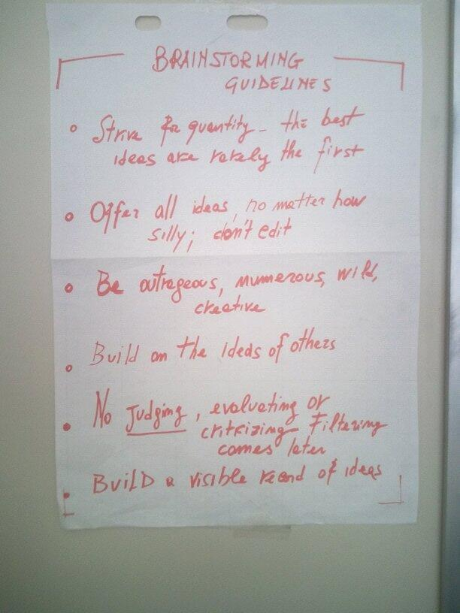

You can approach brainstorming in a variety of ways. But every brainstorming session requires you to facilitate some basic activities or steps:  
**Define the problem**  
**Ensure everyone contributes**  
**Boost creative idea generation**  
**Document ideas**  
and **evaluate ideas**

**Defining the problem**may include working out what the problem is. Or, if you have already been presented with a particular issue, it may involve restating that issue more specifically.  
  
After defining the problem, the next step in the brainstorming process is to start generating ideas. For true brainstorming, quantity is the goal rather than quality. You want to stimulate your team members to put forth all kinds of wild ideas. Evaluation and criticism of idea must wait. For now, every idea is a good idea. Ideas- even the most outrageous ones – will act as inspiration for other people to build on.

To realize the potential of any team, you need to **ensure full participation**. Everyone has something to offer.  
  
As ideas begin to flow and participants get enthused, people may start talking and proposing ideas simultaneously. Vibrant brainstorming sessions can get confusing and chaotic. In the excitement, some people’s ideas may get swept away

One way to avoid this is by giving the team the chance to internally brainstorm beforehand. You can ask team members to compose their own list in private for 10 to 15 minutes before the discussion begins.

As the more dominant members of the group start to monopolize the discussion, the less aggressive members will have their thoughts written down and organized in their own mind. They’ll be more likely to speak up and their input won’t be lost.

Another way to ensure everyone gets a chance to contribute is to set the rule that one person should speak at time. Each person proposes her ideas in turn.

Taking turns, also called sequencing, helps you control and encourage participation. The choice of sequencing isn’t important. You could take turns by going around the table, drawing numbers from a hat, or using some other random method.

Going in turn everyone gets a chance to speak. But to ensure everyone is willing, also try establishing a nonjudgmental atmosphere. If all else fails, and some people are still reluctant to contribute ideas, ask them directly for their inputs.

Brainstorming sessions can stall from time to time. At those points, your **skills for sparking**creative solutions will be needed.

Part of keeping the discussion on track is **documenting** the ideas you generate to avoid confusion.

**At the end** of brainstorming session, you need to **evaluate** the ideas you’ve generated based on whatever criteria will get you the solution you want.

Brainstorming meetings often stall at some point as people run out of ideas and energy. When this happens, you can use techniques to jump start the conversation, boost the team’s creativity, and get things rolling again.

If the meeting stalls, try reversing the problem. Instead of asking “How can we succeed at this task?” ask “How can we fail miserably at this task?” Posing this question may get the discussion going and point to previously overlooked ways to succeed.

Get people to confront the issue from a completely different angle. Try using random words – perhaps from the dictionary – and ask people to make connections from the word to the problem at hand.

You can also stimulate ideas using similes – figures of speech that compare the likeness of two things. Have each team member write down what he believes the challenge is most similar to. After each person has generated few similes, the group evaluates them all, picking the one that’s most analogous. The group then brainstorms solutions to the analogous issue with the hope that some ideas may translate back to the original problem.

As you team generates ideas, documenting those ideas in some way becomes important. Ideally, you should document as you go along to avoid losing ideas and preventing time from being wasted on duplication. You might use a whiteboard, flipchart, or computer to display a list for everyone to see. An alternative approach for documenting ideas that can also serve to jumpstart creativity is a mind map.

Using words and visuals, you can then make each related idea in the center of thought for more new ideas. By allowing team members to visually link elements and associate key ideas, mind maps can help jumpstart as well as organize data.

For a brainstorming session to be effective, judgment can’t be passed on ideas as they’re generated. Evaluation must wait until after you’ve exhausted the possibilities for creative ideas – or until you reach the time or idea limit you’ve allowed. Then you need to analyze what you’ve got to determine which ideas and solutions are valuable and should be pursued further.

You can ask many different questions and use many possible criteria to evaluate ideas:

Is the idea technically feasible?   
Would it appeal to the customer?            
Is it in line with company goals?

Will it make money? (Business Value)

Another method for evaluating ideas is to have team members vote on them based on their merits. Based on the voting, you can rank the ideas.

**Conclusions**

Molding the work environment to promote creativity involves promoting and supporting the characteristics that help people to be creative. Cultivating diverse employee base and a culture that accepts diversity will help increase idea generation by starting with multiple perspectives.

Establishing open communication throughout the organization helps people share and build on ideas, resulting in even more solutions and combinations of ideas. Ensuring that people have sufficient time to explore, experiment with and fully develop their ideas is also essential to a work environment aimed at promoting creativity.

Two “classical” but powerful, when used correctly, techniques were described: Lateral Thinking and Brainstorming, with particular focus on the last one.

**References**

**Driving Growth Through Innovation: How Leading Firms Are Transforming Their Futures**  
2008, Robert B. Tucker, Berrett-Koehler

**How Breakthroughs Happen: The Surprising Truth About How Companies Innovate**  
2003, Andrew Hargadon, Harvard Business Press

What I find incredibly interesting is why defining value is so hard. Agile proponents have been beating the value drum since the very beginning. Put the customer in the room… understand their needs… build what ever they want… deliver software in small increments… get constant feedback… converge on the optimal solution… deliver value early and often. **Agile is all about delivering value.** Why wouldn’t a management team embrace a set of methodologies so focused on giving them what they need the most?

Here is my take…

Agile is (in large part) a reaction to misapplied waterfall development and naive application of project management principles in ways that are inconsistent with how software actually gets built. It was is a reaction to dehumanizing, process and artifact driven management approaches… processes that assumed with enough procedures, we could somehow commoditize the practice of software engineering. We wanted to take the uncertainty out of a craft that is really a blend of engineering and art. Our desire was to make everything predictable and repeatable.

We were trying to treat people like machines that could be infinitely sliced across tasks, tasks that with the right level of process and planning, with the right level of project management and oversight, would somehow magically roll up into working software that our customers would want to buy. Guys like Jefferies, Cockburn, Schwaber, and Sutherland were beginning to realize that successful projects were really the result of high-performing, committed individuals, working together in small teams, all directed toward shared outcomes.

XP, Crystal, and Scrum were born through the realization that these small empowered teams delivered the best outcomes and were the most successful over time. As these agile approaches were beginning to emerge, they all shared this disposition toward small teams, close customer interaction, and frequent delivery of value. The funny thing is that if you talk with most folks working for small companies… this is kind of what they do naturally. Folks are not assigned to a single role… you have a team of high-performing individuals working together for the sake of their collective survival. Big companies seem to have messed this up… but I digress.

Fast forward 10 or 15 years…

Now we have pockets of agile within large organizations… sometimes we might even have agile across entire large enterprises. We are exploring agile methods and trying to see if they can deliver on the small team promise… but in the large. The main difference with these larger organizations is that value isn’t the same as it is in a small team or a small company. There is not a direct correlation between team performance and business outcomes… there is not a direct connection between what the team delivers and what we can sell to our customers. It takes the output of too many small teams coming together to deliver anything of value.

Agile methodologies have typically treated the team like a black box. We give them a prioritized product backlog as an input and we get valuable working software as an output. But now… we have to coordinate the output of several teams… maybe even dozens of teams… into some sort of coordinated deliverable. We are having to deal with getting tens or hundreds of people working together in a coordinated fashion. When that is our context… the message of teamwork and collaboration… close relationships between the team and the customer doesn’t resonate. The only way many of these organizations can get any sense of comfort… any sense they that they are responsibly managing their part of the business… is to ask their teams to commit to the big up front plan

As an organization, we know that we need to deliver value as fast as possible. We know that we need to be able to respond to change. We know that we need to deliver with more predictability and with higher quality. We have an intuitive sense that what we are doing isn’t working. We want to get benefits that agile talks about. We suspect that something like Scrum or XP can help… but we can’t figure out how to apply the small team concepts to our particular business problems. That’s why you get the classic “agile will never work here ” comments. There is an inherent disconnect between the team level guidance agile methodologies talk about and the bigger concerns your senior executives are struggling with.

There is a gap between value at the team level and value at the enterprise level.

At the end of the day, our community needs to develop guidance that helps our executives get the benefits of agile but focuses on real, enterprise class value delivery… value defined in terms of real results and real business outcomes. So, why is agile a tough sell? We are asking our leaders to trust a process that focuses on team based outcomes but doesn’t give them a credible way to articulate how the development organization is going to deliver on the more complex objectives of the business.

- See more at: <http://www.leadingagile.com/2009/12/why-is-agile-so-hard-to-sell/#sthash.RATOsIru.dpuf>

## Methodology per Project

From the preceding sections we should see that there are many, legitimately different methodologies (see Figure 9). It is not the case that the national bank’s Year 2000 project, the space shuttle software project, an overtime food request project, a promotion tracking project and a word processor software project should all run the same way. They differ at least by the he number of people involved, the criticality of the project, and the project priorities.

In Figure 9, I divided the space into seven project sizes and four zones of criticality. These are arbitrary but plausible divisions, set approximately where my experience indicates that the methodology is likely to take on a different nature. Within each cell, a different methodology may be called for. Each cell admits of several methodologies, depending on whether the project leaders are in search of productivity, visibility, repeatability, or correctness. The methodologies will get larger (more communication elements) toward the right, and denser (tighter controls) going up, hence heavier moving up and to the right, or lighter, moving down and to the left. According to principle 3 above, moving to the right or up adds a large cost to the development of the project, so there is economic incentive to consider a project to sit as far to the left and down as possible. Other incentives, such as prestige and career safety, act at the same time, so it is hardly the case that methodology selection will ever be completely objective.

The grid is relatively objective. We can count the number of people on the project, discuss its criticality and priorities. Using the principles underlying methodologies in general, we can make some basic decisions about the methodology to be used. After that, personal preferences and principles will drive the details of the methodology design. The next section discusses how these ideas have been used on three projects.

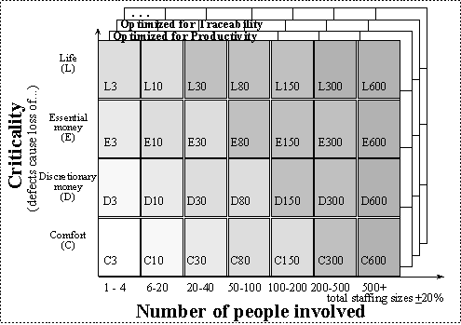

**Figure 10**. Methodologies, organized as people x criticality x optimization.

<http://www.devx.com/architect/Article/32836/0/page/4>